EShop Cart:
This application I have create around couple of hours including both client and API side development. This is very basic level application and if time would have permitted me, I would have done it much more user friendly.
The Main functionality I have tried to cover here is display the items in cart, add or remove the items. If items are already available for user, it will get updated with quantity.
Clear all in API side done however could not get chance to provide provision from UI side.
Technology : C#,
Framework: .Net Framework 4.6.1
Tool: Visual Studio 2017

Assumptions:
User is authorized and so why allowed to add, remove items in car.
As due to time limit, I have preferred to keep data as static for product (items) master list. Otherwise I would have kept data in database.
API : This is the post request API to add (post) the data at backend (To keep it as simple data is added in memory) .
url : http://localhost:58253/api/ManageCart
Request Object:
var Basketa = {
"User": "10",
"Products": [
{
"ProductId": "1",
"Quantity": 24,
"Price": 12,
"Total": 100
}, {
"ProductId": "2",
"Quantity": 10,
"Price": 12,
"Total": 100
}, {
"ProductId": "3",
"Quantity": 12,
"Price": 12,
"Total": 144
}]
};

Response :
Success or Failure

Note:
Both projects are under one solution and are multiple start up projects.
On execution of project, 2 windows will open as both are dependent on each other. So while calling API project should be running in background.

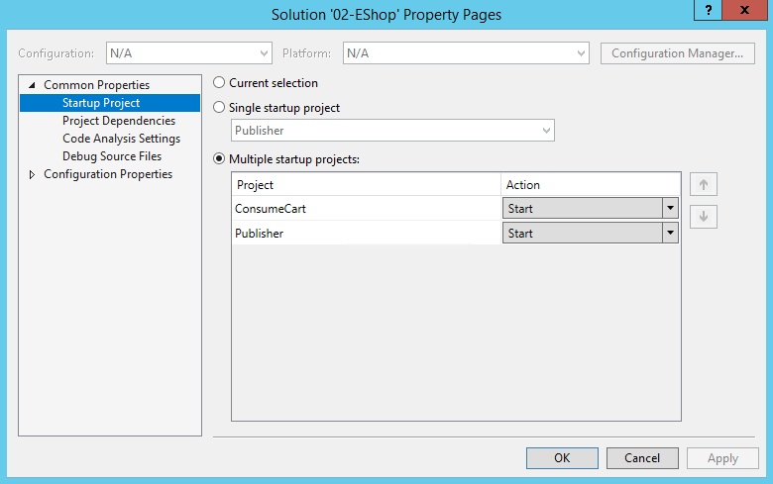

UI:
Below is the UI for client application. Made in JQuery, HTML , CSS as the reason is to have it light weight.
